49 Bespoke

1).

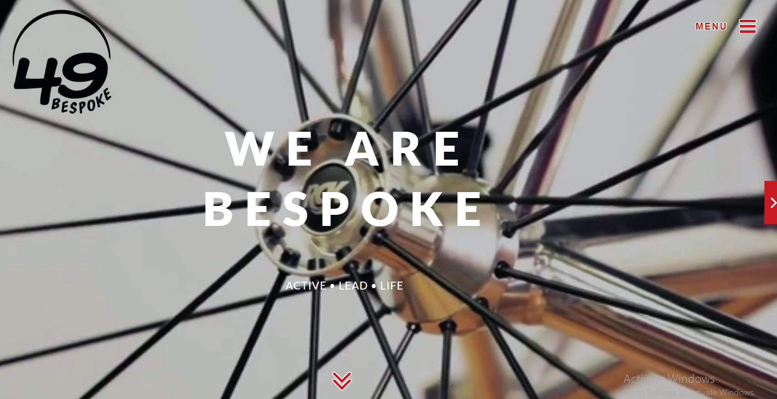

Both have same functionalities, i.e.

Taking the page downwards

2). 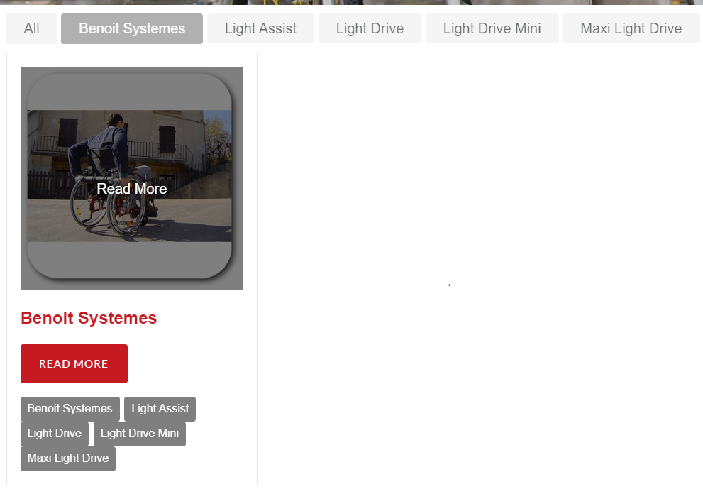

Wrong spelling

“Systems”

This looks ugly

This “READ MORE” take to the page

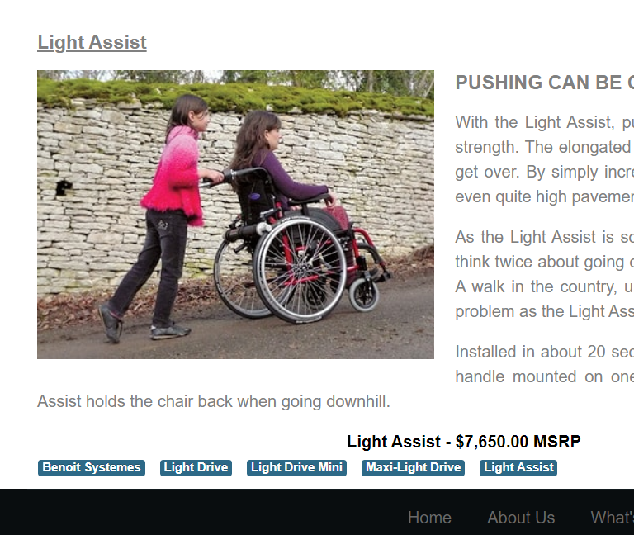

These links donot work they take us to the empty page.

3). 

They do not work

These all links take us to one single same card

4). When I search wheelchair in the “SEARCh” part the I got to know about various good quality products that should be visible to user on front page rather than typing and then getting it.

5). Online store page looks messy

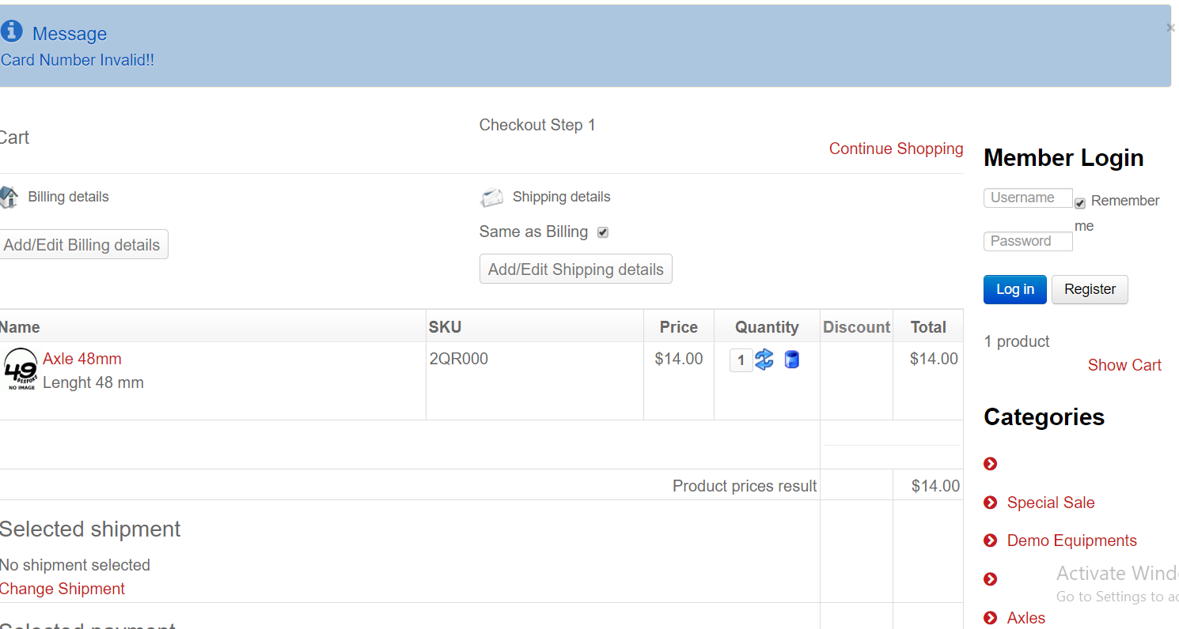

Blank options in category slot

messy

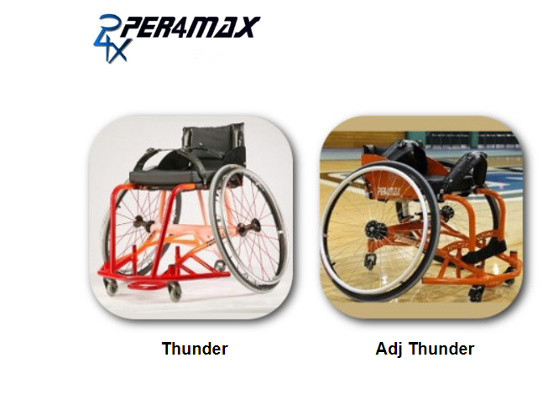

**images do not get enlarged**